Plain Email Signature and Instructions
https://www.utsa.edu/marcomstudio/resources/toolkits-templates/email-signatures/
To save your email signature, either copy from the link above or follow the instructions below:
- In Microsoft Outlook, select the button to create a “New Email”
- Click on the “Signature” Button, then select “Signatures” from the drop down menu
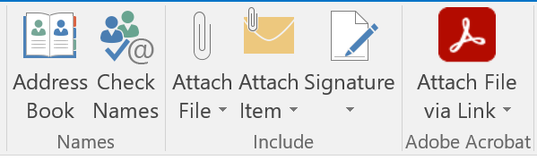
- Select “New” and enter a name for your new signature.
- Copy (Ctrl-C) the signature and format below
- Paste (Ctrl-V) the signature template, then customize your personal information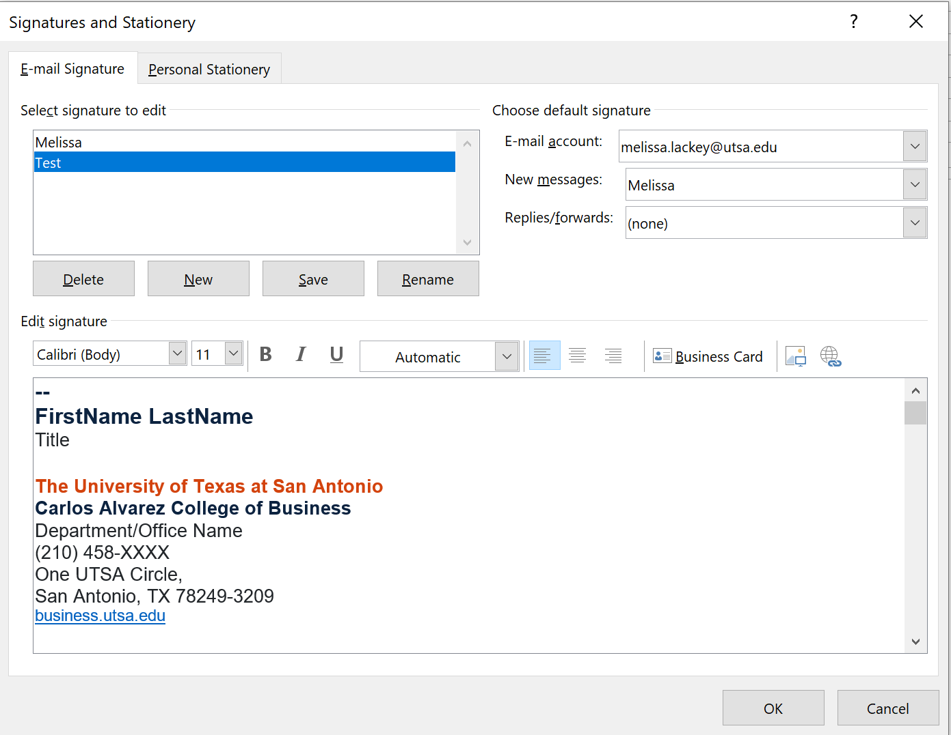

- Select OK to save your signature

--
FirstName LastName
Title
The University of Texas at San Antonio
Carlos Alvarez College of Business
Department/Office Name
(210) 458-XXXX
One UTSA Circle,
San Antonio, TX 78249-3209
business.utsa.edu

